VMECA’s VCC Vacuum Conveyors
This week we’re showcasing VMECA’s VCC Vacuum Conveyors, specifically, a chemical material transfer application using the VCC200 model. Designed for the safe handling of hazardous or sensitive materials, the VCC200 moves product through a fully sealed vacuum system to ensure controlled, dust-free conveying. By minimising operator exposure and preventing material loss, the system supports safer, cleaner, and more efficient handling of chemical raw materials, powders, and bulk substances that require secure and hygienic transfer.
Video here: ……………
VMECA’s VCC Series Vacuum Conveyors
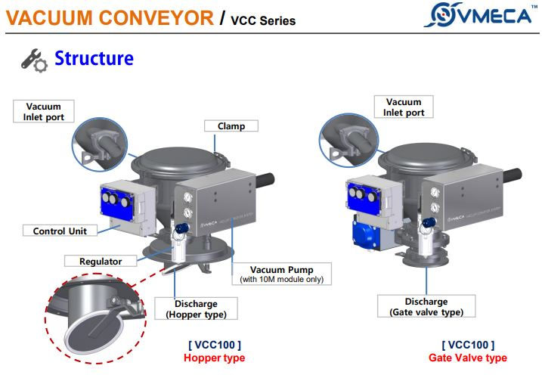
Key Features:
• Compact design ideal for installations with limited headroom
• Configurable supplementary features to suit a wide range of applications
• Dust-free conveying of dry powders, food products, pharmaceuticals, chemicals, plastics, and free-flowing granular materials
• High-quality polished 304/316 stainless steel construction; food-grade and acid-resistant
• Low maintenance design with self-cleaning filtration, delivering high conveying capacity from 0.4 TPH to 1.5 TPH

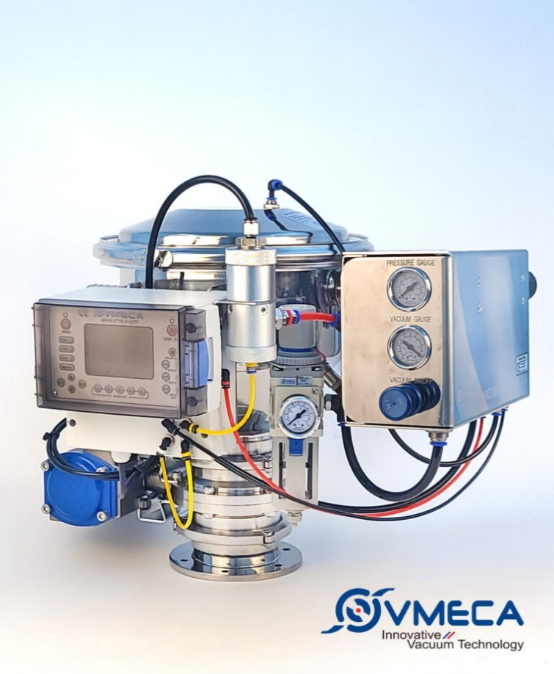
Below is VMECA’s Gate Valve Type Vacuum Conveyor VMECA Vacuum Conveyors
VMECA Vacuum Conveyors use vacuum pressure to pick up and transfer materials. This process operates on a pressure differential created as atmospheric air moves to equalise areas of differing air pressure, generating the suction required for conveying.
Vacuum conveying provides a simple, clean, and hygienic material handling solution. When transferring powders and granules, it is essential that the process remains safe, prevents product degradation, and protects both operators and the environment. To meet these requirements, Simmatic offers a complete range of VMECA vacuum conveyors and material handling solutions designed to comply with the highest hygienic standards - while remaining cost-effective.
Each system can be tailored to the specific application. Our experienced engineers evaluate and test every solution to ensure all operational, safety, and performance requirements are met for efficient and reliable operation.
VMECA vacuum conveying systems offer a straightforward way to enhance business performance by improving productivity, process efficiency, and material handling reliability.

Explore product details 👉 New & Improved Vacuum Conveyors

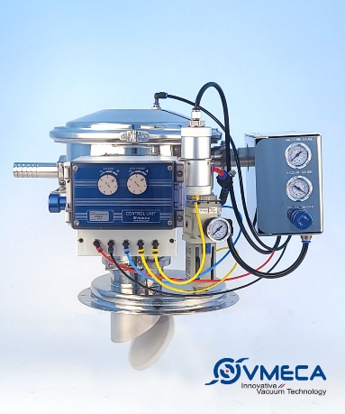
VMECA’s New VCC Hopper Type Vacuum Conveyor →
For more information about VMECA VCC Vacuum Conveyors, or any of our pneumatic and vacuum handling solutions, please contact Simmatic on 01299 877770 or email sales@simmatic.co.uk
Whatever your project requirements, we’re always keen to work with you and guide you through the available options. With a wide range of automated solutions, Simmatic has the expertise and products to support applications involving moving, holding, pushing, gripping, pulling, lifting, or lowering - delivering the right solution for your operation.

We invite companies to “Challenge Us” with their industrial vacuum handling applications. If you have difficult or unconventional products to handle, our team is ready to help find the right solution.
Visit Simmatic’s YouTube channel to subscribe and explore our full range of vacuum and material handling solution videos.

#VMECA #VacuumConveyor #VCC200 #ChemicalHandling #MaterialTransfer #PowderConveying #BulkMaterialHandling #IndustrialAutomation #ProcessSafety #DustFree #SmartFactory #Manufacturing

VMECA, VacuumConveyor, VCC200, ChemicalHandling, MaterialTransfer, PowderConveying, BulkMaterialHandling, IndustrialAutomation, ProcessSafety, DustFree, SmartFactory, Manufacturing

https://simmatic.co.uk/2023/11/new-improved-vacuum-conveyor/

